|  |  |
| --- | --- |
| TORONTO REAL ESTATE REPORT  Capstone Project | Abstract  This report will give an in-depth analysis on how Toronto real estate price affecting by surrounding amenities.  Sheldon Li |

# Background

Toronto is the provincial capital of Ontario and the most populous city in Canada, with a population of 2,731,571 as of 2016.(wikipedia). Its gorgeous environment, diversified community and work balance life style attracts thousands of people choose to work, study and live here, which made Toronto is the one of the most expensive city in the world.

This report will analysis relationship between surrounding amenities and house price in each neighbourhood in Toronto.

## The city

The table below shows the neighbourhood of Toronto

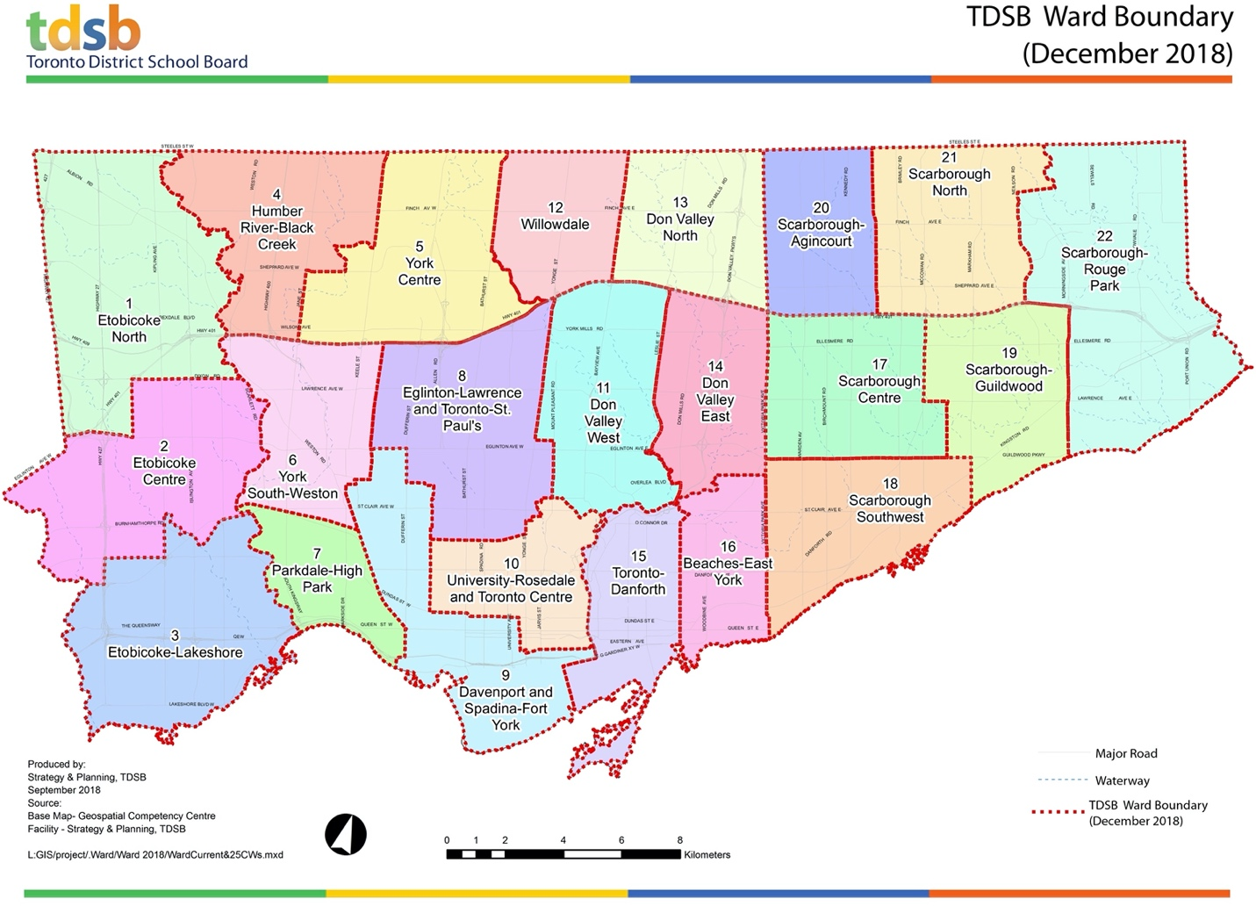

### Data Cleaning

Download data from various sources and merge different tables into one using Python pandas. I got average house price in each neighbourhood sorted by postal code. Geographical coordination will be used for generate the most popular places in each neighbourhood.

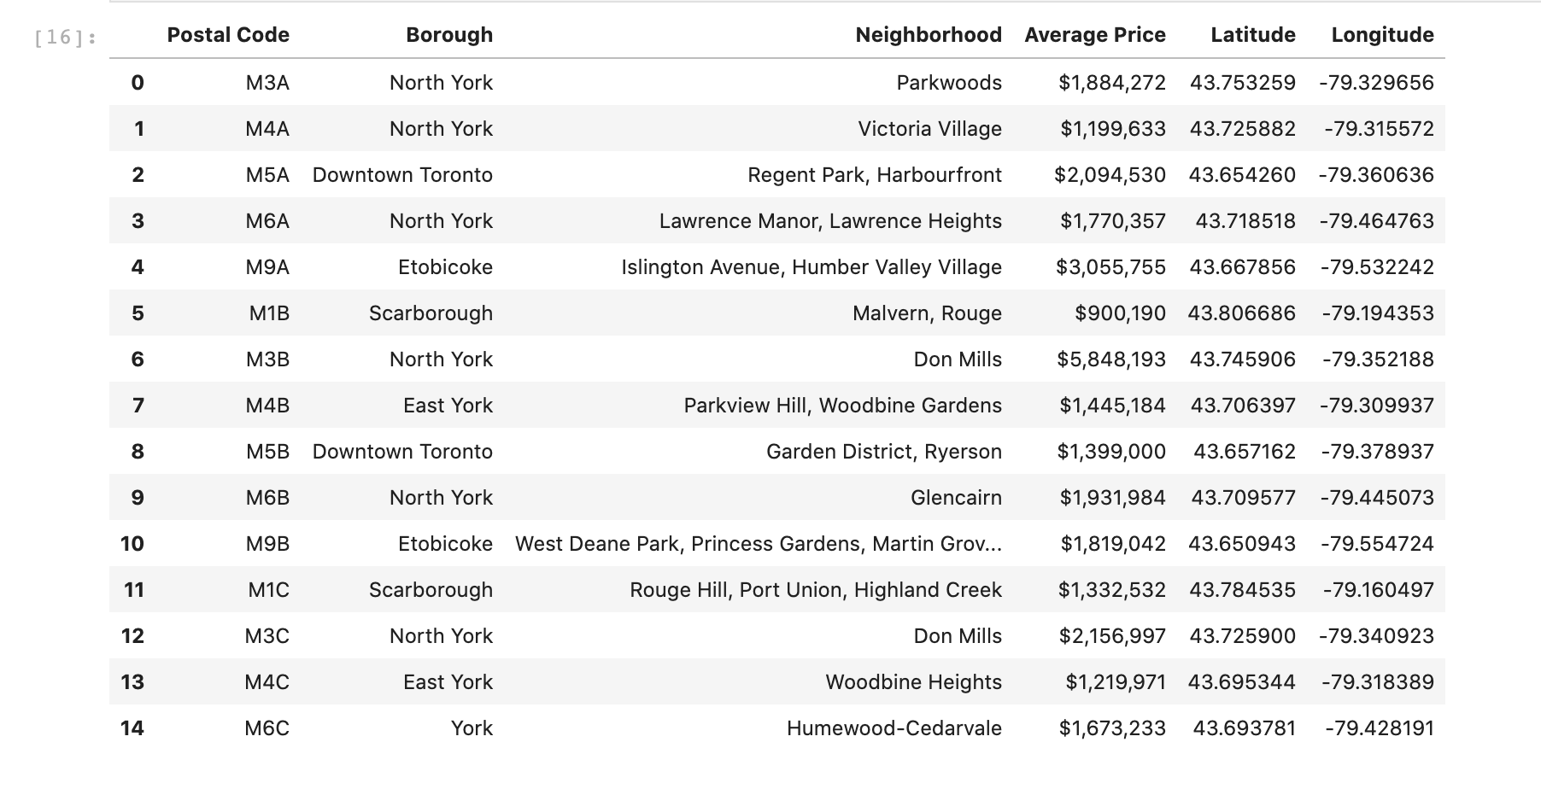

The following graph shows the average house price in each neighbourhood of Toronto:

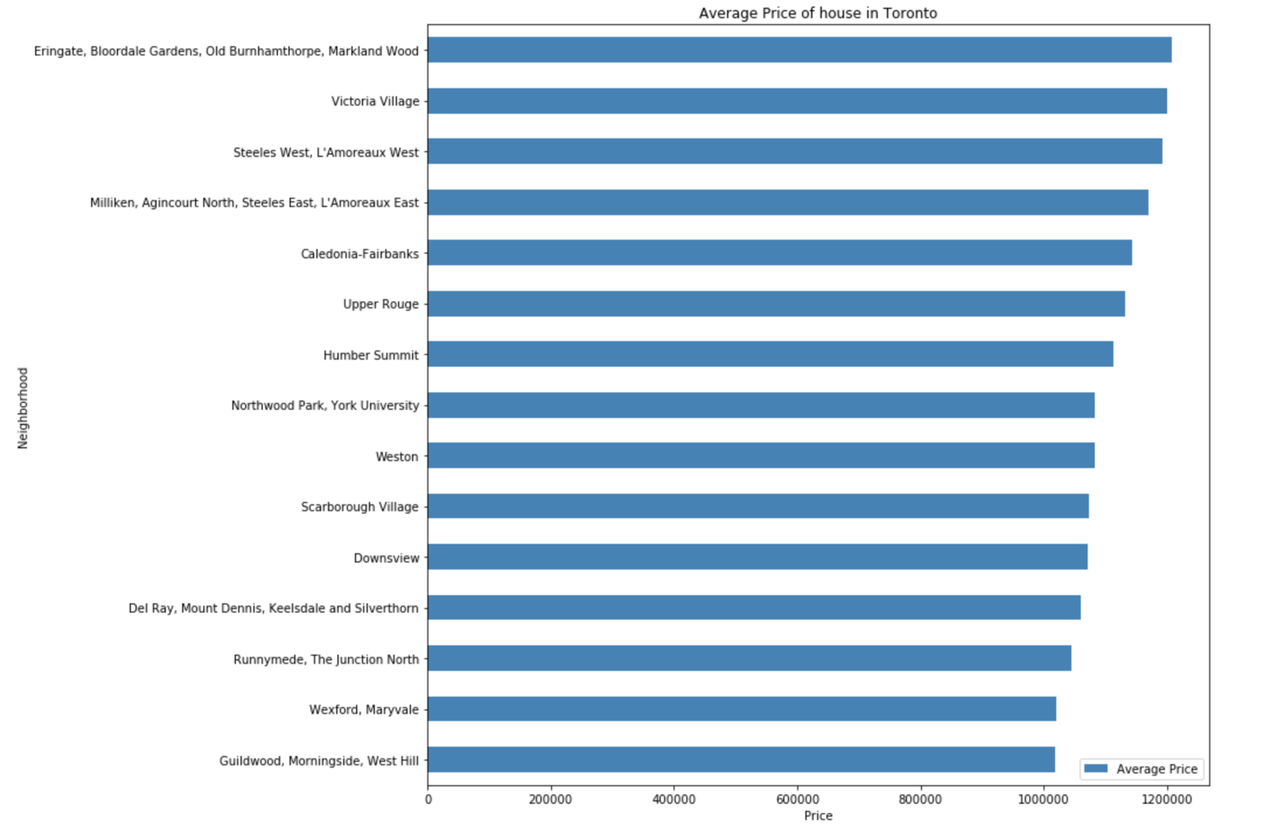

According to the graph, we know the top 15 house price ranking in each neighbourhood. Now, let’s take a look the surrounding facilities in those areas.

To do that, I used Foursquare API to obtain the most popular places that people usually visit, and from those data, we could know that kind of people are living in the neighbour and how it would affect the house price.

First, let’s take a look the top 10 popular places that people choose to go.

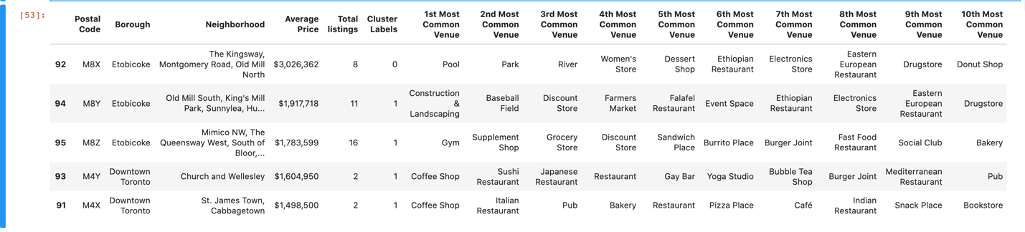

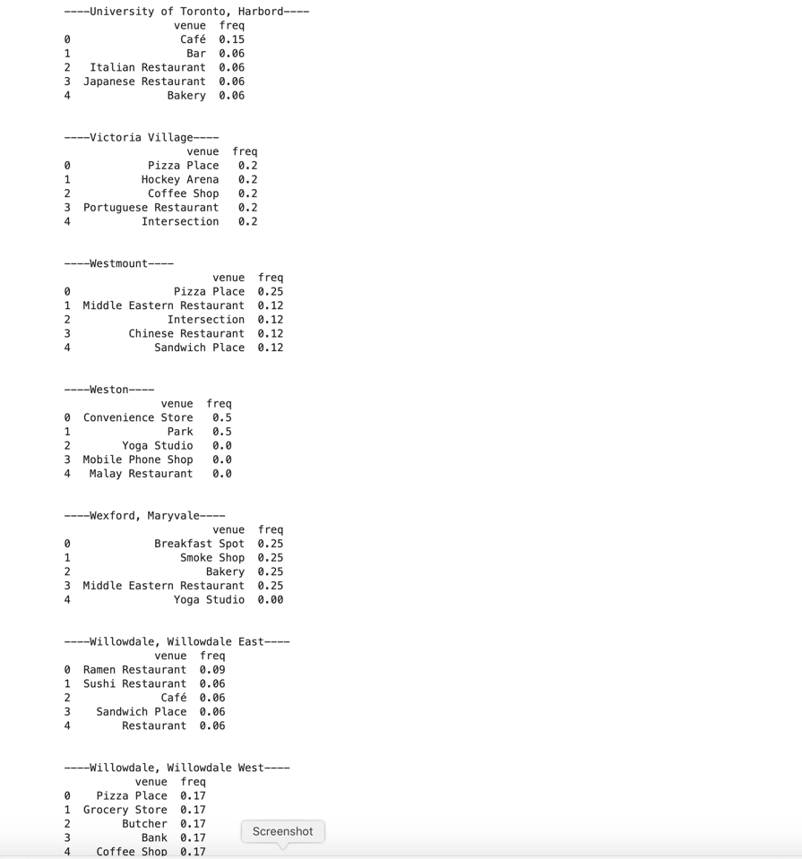

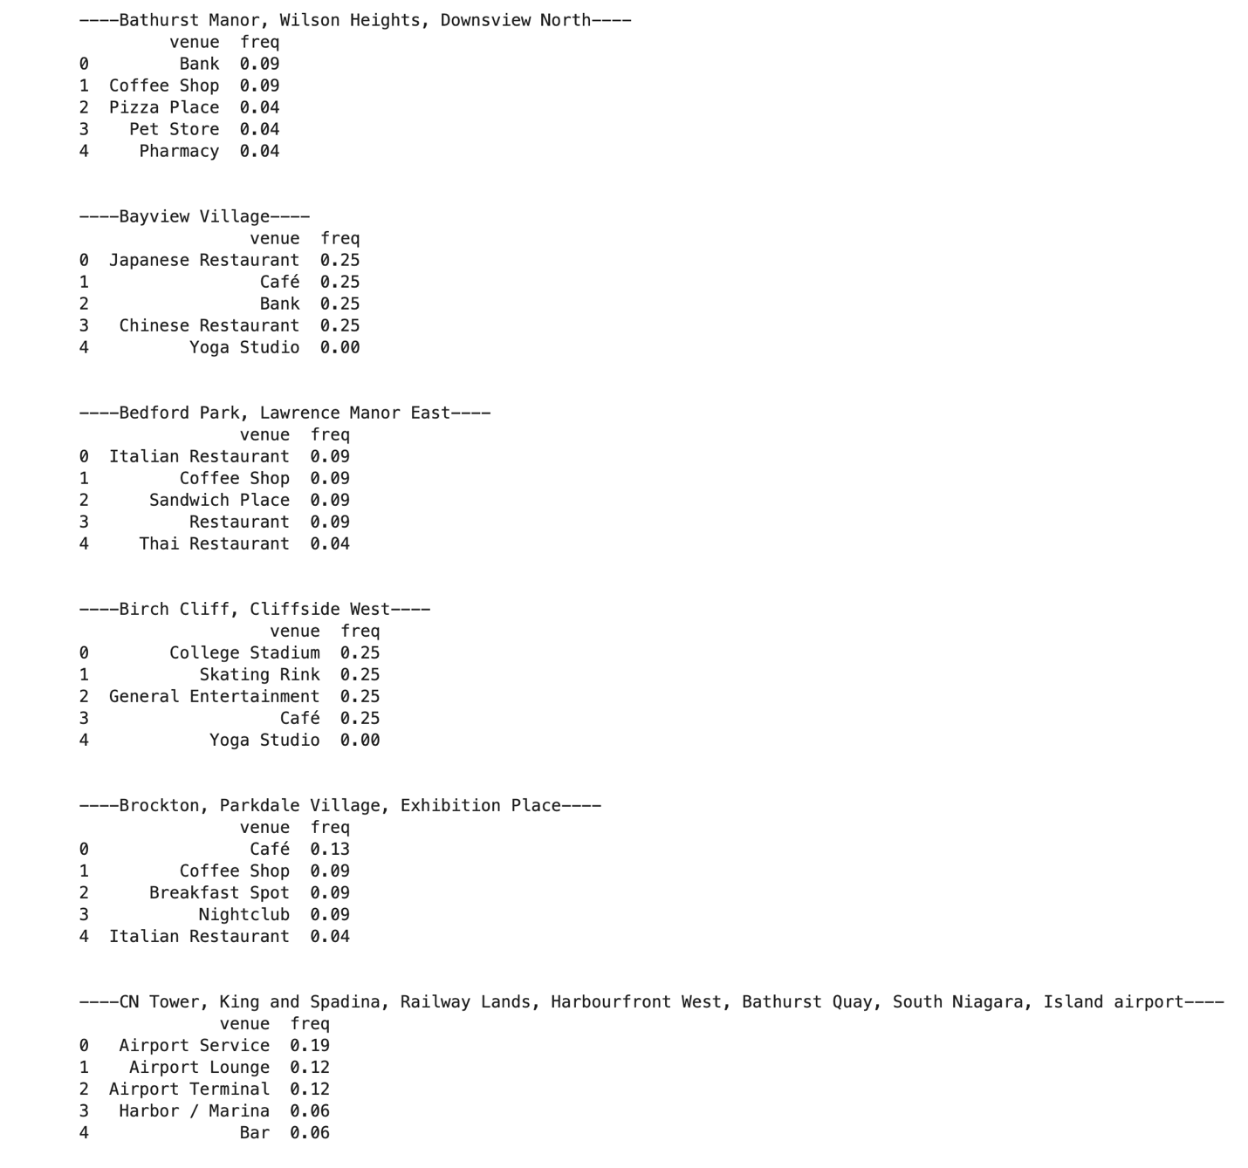

According to the table, Etobicoke area is more casual than downtown area because pool, park and river are the most visited venues. Therefore, Etobicoke is a residential area with natural recreational amenities.

If we take a look at the most visited places in Weston, which are convenient store, cellphone shop and park. Then, we see it on the map, thus, we have an insight that that area is located in a far and less populous area. You may wonder why the house price still high considering it is nearly out of the town. One reason is that there is a GO train station in the area that people can go to Toronto downtown within 30 mins.

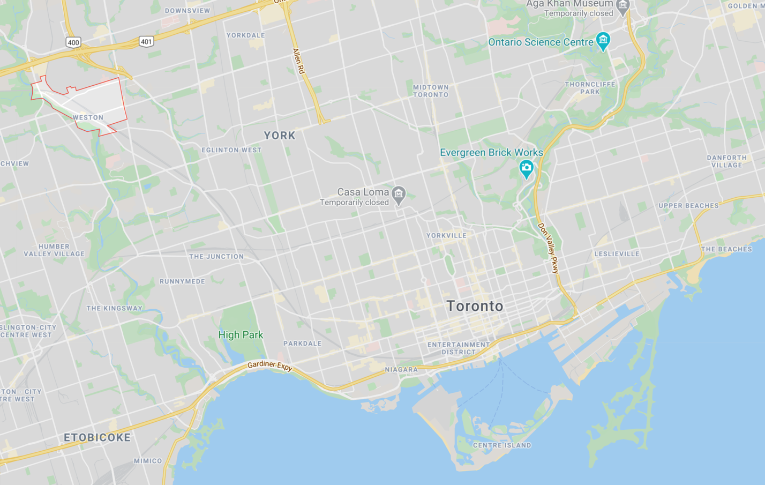

# Conclusion

In conclusion, the location and surrounding amenities will affect the value of the house. People would like to live near a park, lake and a recreational center. Houses near those amenities usually have higher price than houses are not.